|  |
| --- |
| INVESTMENT APPRAISAL & VALUATION  19th July 2019 |

|  |  |
| --- | --- |
| Word count: 1,960 | [https://www.givingtuesday.org.uk/wp-content/uploads/henley-business-school-logo.png](https://www.google.co.uk/url?sa=i&rct=j&q=&esrc=s&source=images&cd=&cad=rja&uact=8&ved=2ahUKEwj01oDQorLhAhVPDWMBHRGMBzkQjRx6BAgBEAU&url=%2Furl%3Fsa%3Di%26rct%3Dj%26q%3D%26esrc%3Ds%26source%3Dimages%26cd%3D%26ved%3D%26url%3Dhttps%253A%252F%252Fwww.givingtuesday.org.uk%252Fpartners%252Fhenley-business-school-logo-2%252Fhenley-business-school-logo%252F%26psig%3DAOvVaw3dwN1VvjAd4s3zbT2Mgcjy%26ust%3D1554324093237546&psig=AOvVaw3dwN1VvjAd4s3zbT2Mgcjy&ust=1554324093237546) |

|  |
| --- |
| be832924 |
| colored transparent rectangle |



REMF45



33 KINGS WAY

LONDON WC2

Contents

1.0 Executive Summary2

2:0 Introduction3

3:0 Discussion of inputs for the market valuation4

4:0 calculation of Market value6

5:0 Discussion of inputs for the discounted cash flow9

6:0 Calculation of Investment value11

7:0 Sensitivity analysis 13

8:0 Overall recommendations 15

9:0 Conclusions16

10:0 References17

11:0 Appendices18

* A valuation of 33 Kingsway road London WC2 has been undertaken.
* The current rent for 7 tenants was found to be under the market rent of £63 sq. ft.
* Ascential events (Europe) has paid above market rent at £71 sq. ft.
* A market value of £80,900,000 has been established.
* An investment value of £18,460,000 has been found after conducting a cash flow valuation.
* It is recommended the investor holds this asset for 5 years.

|  |
| --- |
| 1:0 Executive Summary |

This is a valuation for 33 Kingsway, WC2 office build in Holborn. The building is of mixed used with retail on the lower floors and office spaces above.

This build is situated in close proximity to bars, cafes and restaurants. As well as this the build has good transport connections with Holborn station less than a 5 minute walk away and less than 10 minute walk away from Temple station.

This building is a 4 CoStar rated building and has amenities such as near-by bike racks and air conditioning.

33 Kingsway is set to attract large companies in the fashion industry looking for office space.

|  |
| --- |
| 2:0 Introduction |

|  |
| --- |
| 3:0 Discussion of inputs for the market valuation |

3:1 Market Rent

3:1:1 Comparable Evidence

71 Kingsway (Most comparable)

71 Kingsway, Holborn, London, WC2B 6ST

* [](https://www.google.co.uk/url?sa=i&rct=j&q=&esrc=s&source=images&cd=&ved=2ahUKEwjX5_DIka3kAhVOzYUKHceoAtIQjRx6BAgBEAQ&url=https%3A%2F%2Fpw-pdf-bucket.s3.amazonaws.com%2Ffarebrother%2Ffarebrother%2F71-kingsway-london-greater-london-wc2b-6st.pdf.pdf&psig=AOvVaw00UrRQ1bLKQIH08K-6Xnn9&ust=1567341791184281)4 Star office build (Costar)
* Situated 0.1 miles north of the subject

property

* NIA of 30,092 sq. ft.
* Built in 1908, renovated in 2011

71 Kingsway comprises of 26,225 sq. ft. of office space and 3,867 sq. ft. of retail space. The masonry build, positioned moments away from Holborn underground is also in close proximity to restaurants, bars and clothing stores. Renovated in 2011, 71 Kingsway is less than a 2 minute walk away from the subject property.

71 Kingsway has just under 70% let to tenants including financial institutions such as Nexia International Ltd and SV Health Investors LLP. The most recent lease was signed 3rd March 2019. This was on an FRI basis on the 2nd floor. 1,706 sq. ft. was leased at £62.50 sq. ft for 5 years for office use.

71 Kingsway is the most comparable to the subject property due to the proximity as well as the available amenities both share. The quality of both builds are also very similar, with 71 Kingsway being renovated in 2011 and 33 Kingsway in 2012. Both are 4 star rated on CoStar.

10 Fetter Lane (Lower Quality)

10 Fetter Lane, Holborn, London, EC4A 1BR

* [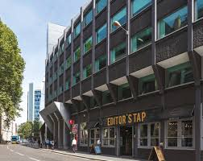](https://www.google.co.uk/url?sa=i&rct=j&q=&esrc=s&source=images&cd=&ved=2ahUKEwjz87vynq3kAhVL6RoKHcENBOwQjRx6BAgBEAQ&url=https%3A%2F%2Fwww.farebrother.com%2Fproperties%2Fdetail%2F173&psig=AOvVaw3zG_tUxBg1KtOKODiHRvTq&ust=1567345433848964)4 Star office build (Costar)
* Situated 0.6 miles east of the subject

property

* NIA of 48,247 sq. ft.
* Built in 1957, renovated in 2011

10 Fetter Lane comprises of 33,096 sq. ft. of office space and 15,151 sq.ft of retail space. The 9 story build positioned minutes away from City Thameslink station is also in close proximity to restaurants and bars as well as a 10 minute walk away from St. Paul’s Cathedral. Renovated in 2011, 10 Fetter Lane is less than a 15 minute walk away from the subject property.

10 Fetter Lane has no available space to let to new tenants as of 31st August 2019. Current tenants include the multi chain bar Slug & Lettuce as well as a law firm Civil & Commercial Cost Lawyers Ltd. The most recent lease was completed on 6rd July 2019. This was on an FRI basis on the 5nd floor for 5,740 sq. ft at £59.50/sq. ft.

10 Fetter Lane is less comparable to the subject property than 71 Kingsway due to the proximity being futher than 71 Kingsway. Both builds have obtained a 4 CoStar rating; however, 10 Fetter Lane is constructed using reinforced concrete while 33 Kingsway is a masonry build.

Swan House (Higher Quality)

Swan House, High Holborn, London WC1V 6AA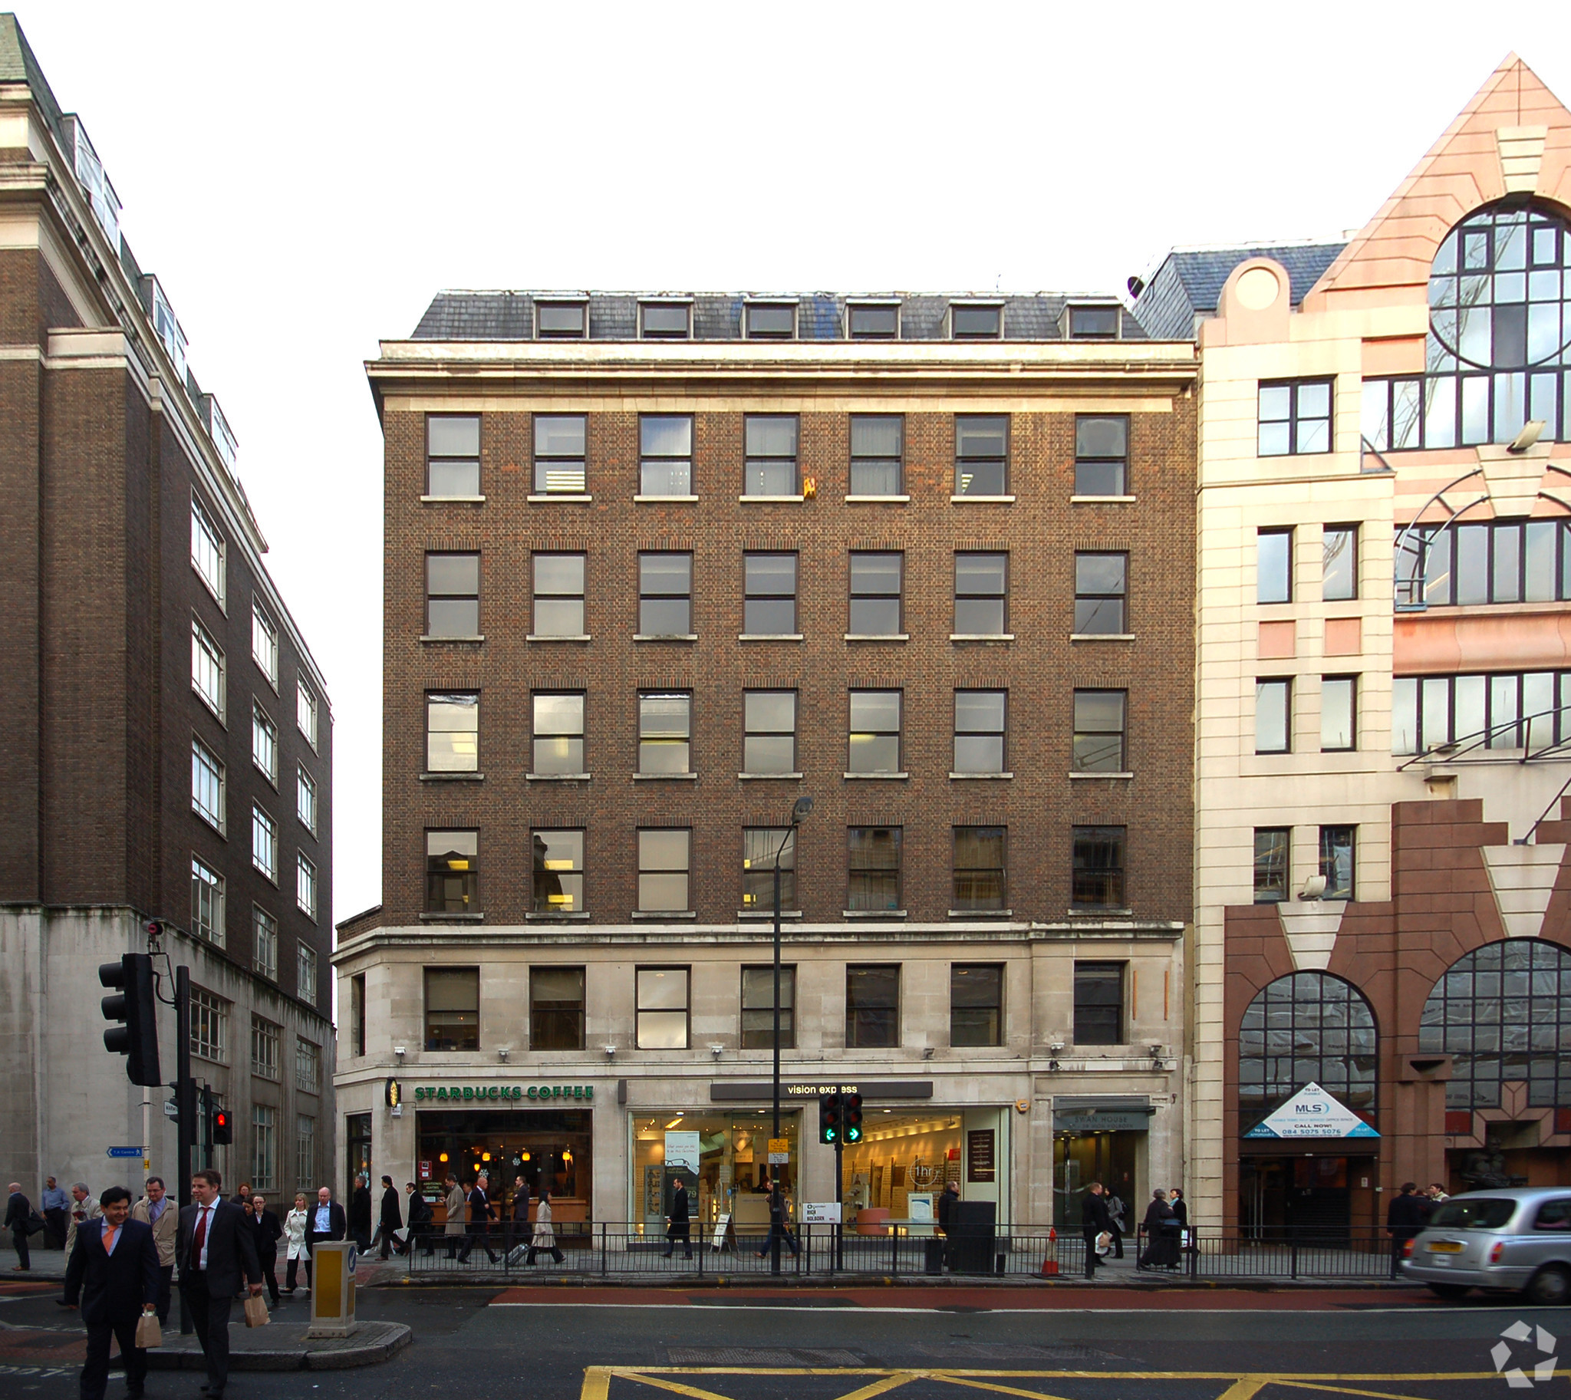

* 4 Star office build (Costar)
* Situated 0.5 miles north-east of the subject property

* NIA of 18,880 sq. ft.
* Built in 1956, renovated in 2006

Swan House comprises of 13,820 sq. ft. of office space and 5,060 sq. ft of retail space. The property is situated on the north side of High Holborn and is closer than the subject property to Holborn underground station. Swan House has close amenities such as a Starbucks, retail shops as well as cafes, restaurants and an optician.

Swan House is 100% occupied as of 31st August 2019. Current tenants include Vanix LLP and Centre for Transnational Legal Studies. The most recent lease was completed on the 22nd June 2022. This was a direct let to True Europe LLP on the 4rd floor. The lease was completed for 2,228 sq. ft at £67.50.

Swan House is of higher quality to the subject property due to the proximity being closer to Holborn station. Both builds have obtained 4 CoStar ratings, and both are masonry builds.

3:1:2 Market Rent for 33 Kingsway

Market Rent

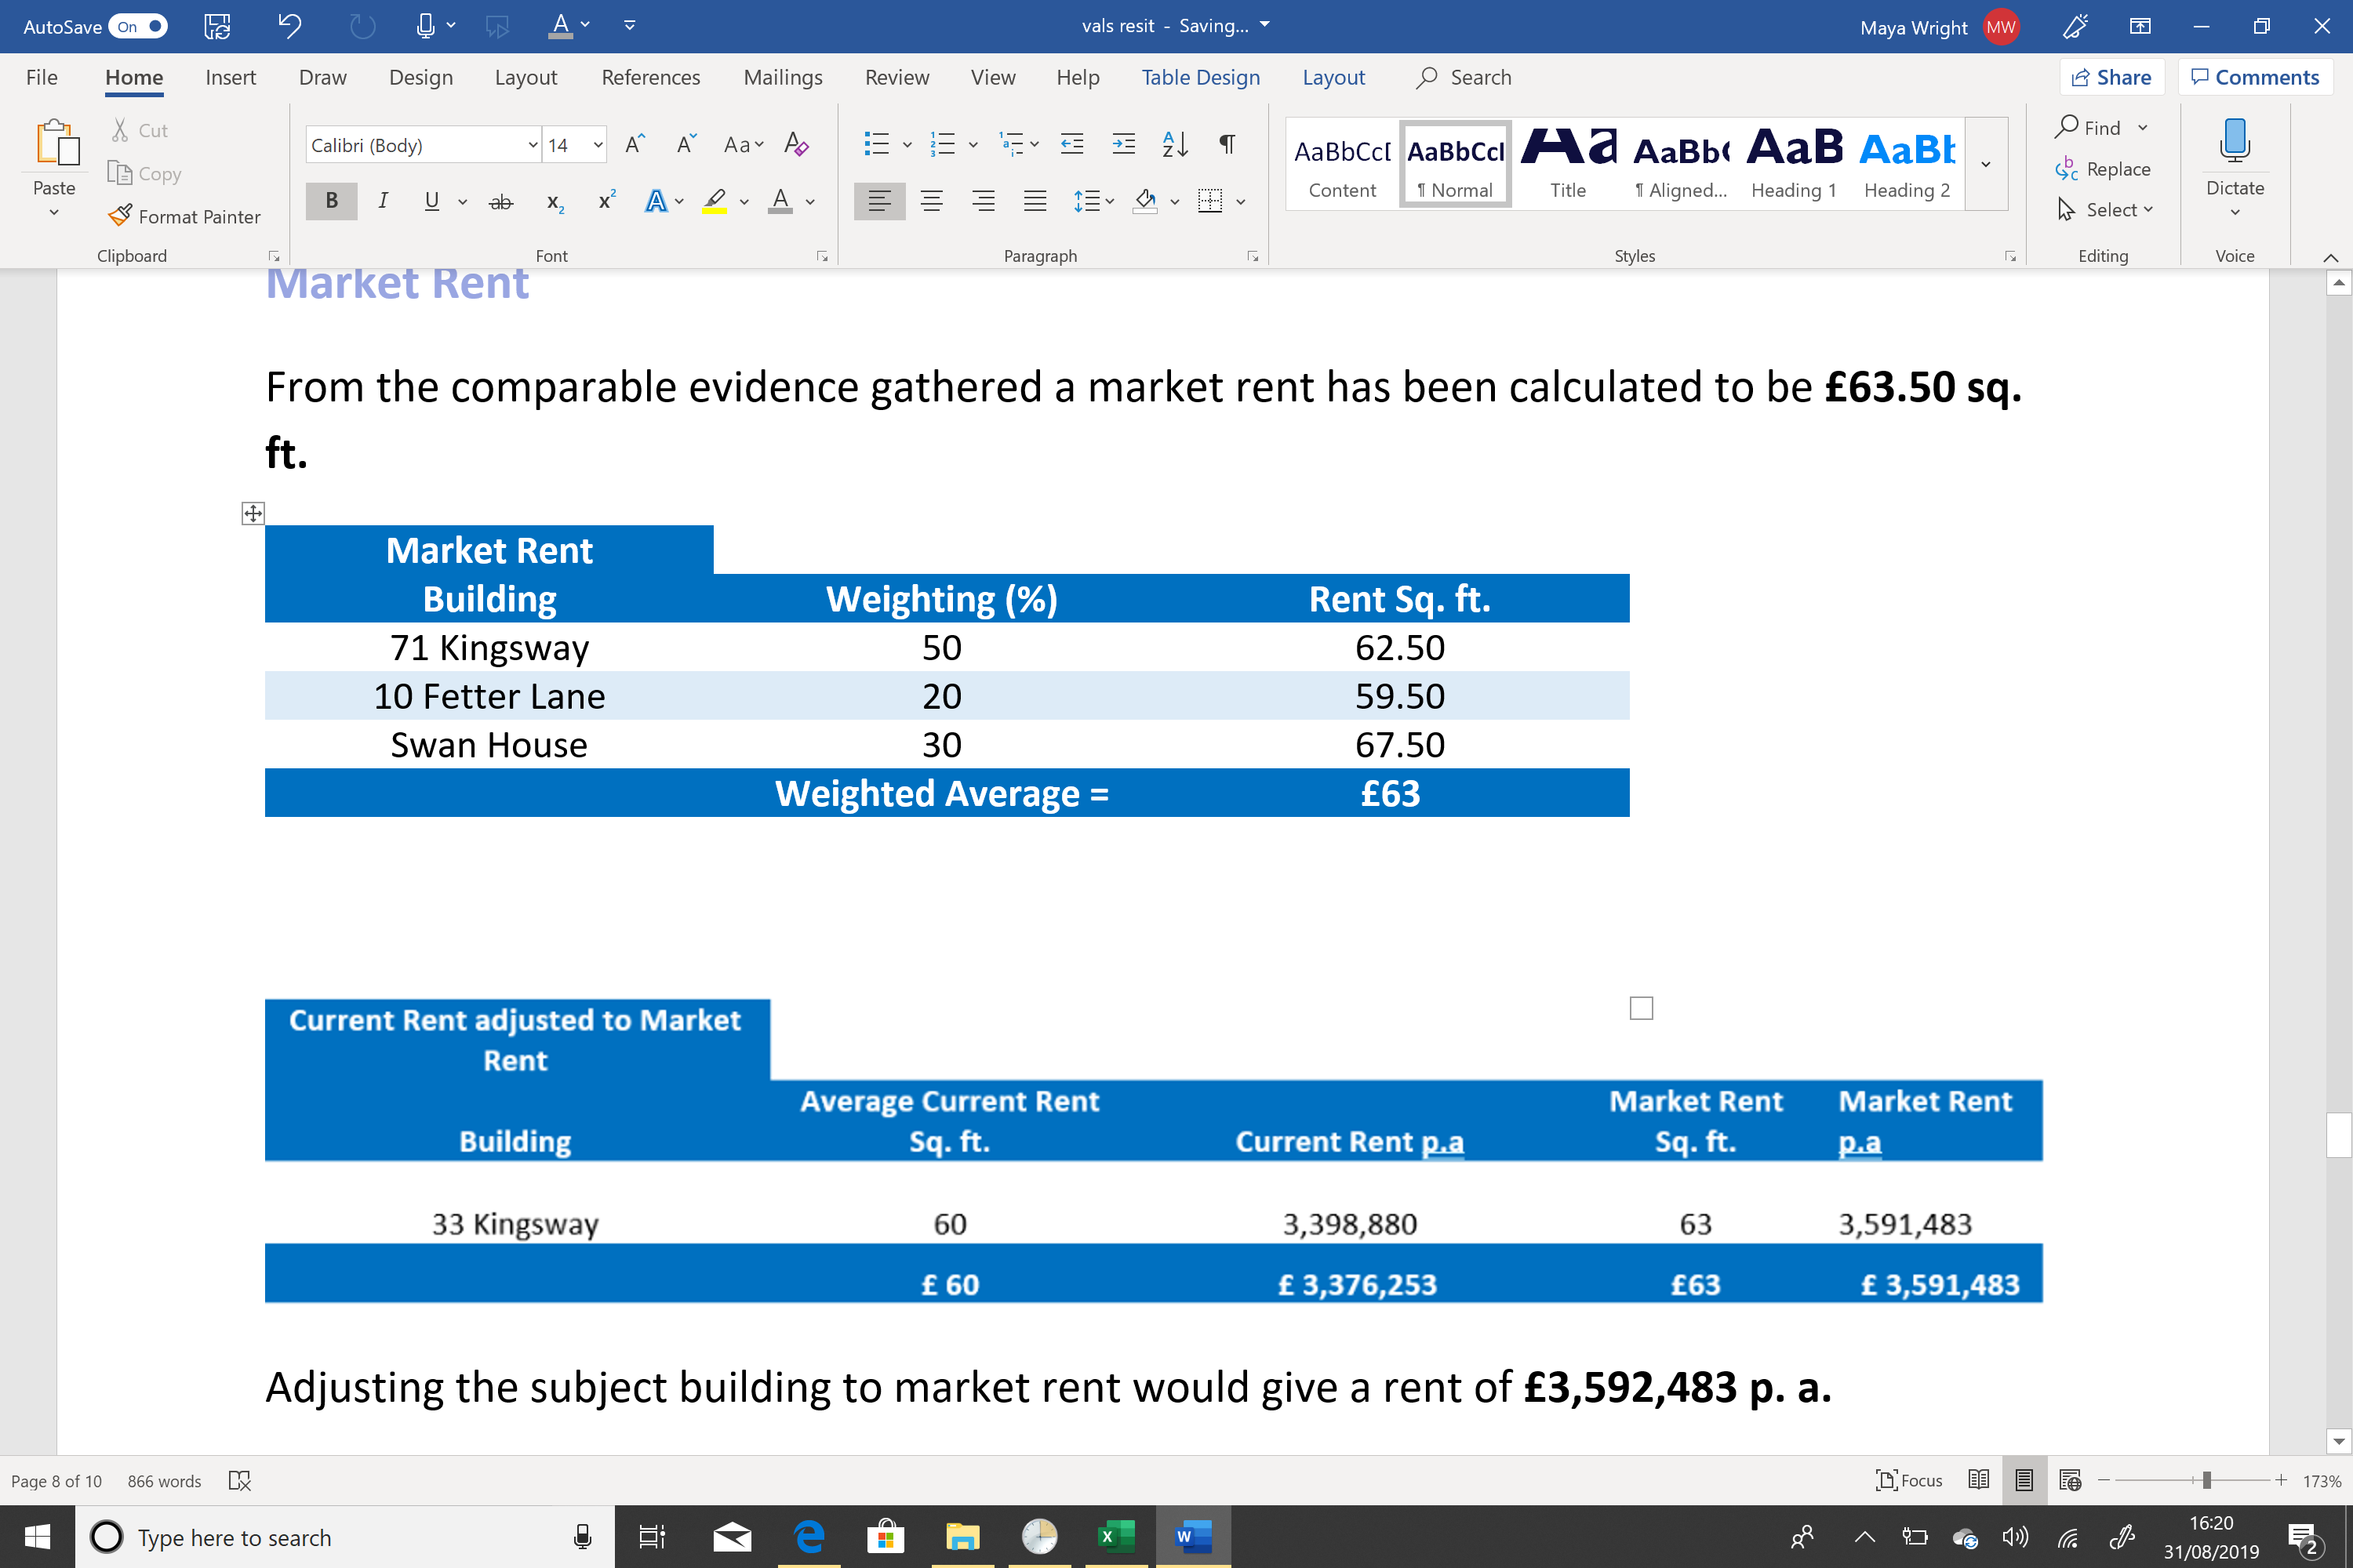

Table : Market Rent derived from comparable buildings

From the comparable evidence gathered a market rent has been calculated to be £63.50 sq. ft. (see Table 1.)

Market Rent for 33 Kingsway

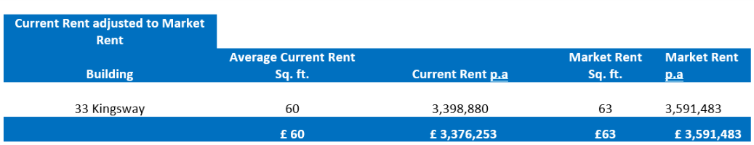

Table : market rent adjusted for 33 Kingsway

Adjusting the subject building to market rent would give a rent of £3,592,483 p. a. (see Table 2.)

3:1:3 Market rent commentary

33 Kingsway is around £3 sq. ft below the average price of comparable buildings of similar quality, location and size. This can be mitigated with new tenancy leases as well as refurbishment.

|  |
| --- |
| 4:0 Market Value |

4:1 Market Value

4:1 Net initial yield

Given that the most comparable buildings for market rent did not have sales within the past year the net initial yield has been taken from the forecast data for 4-5 star buildings in Holborn on the CoStar website. This is typical of what similar buildings are yielding in the area.

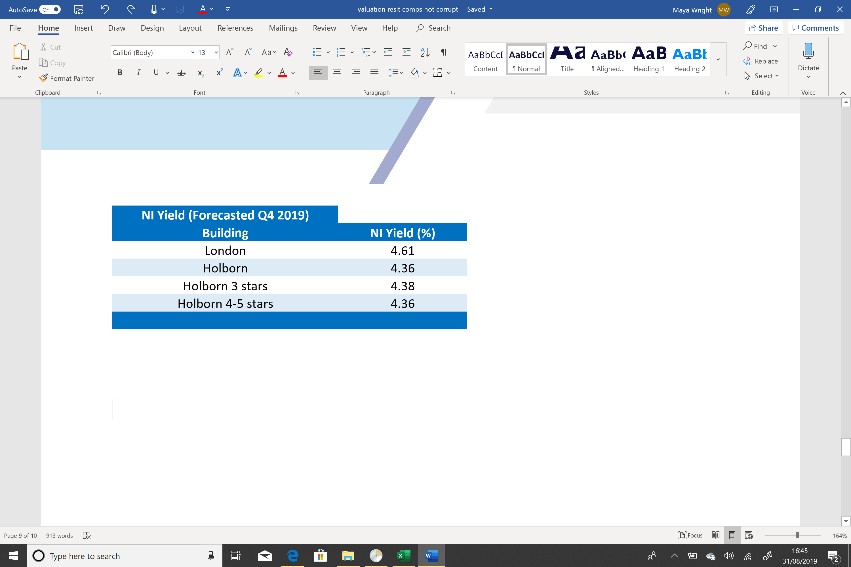

A NI yield of 4.36% has been given for the market valuation.

3:1:2 Market value for 33 Kingsway

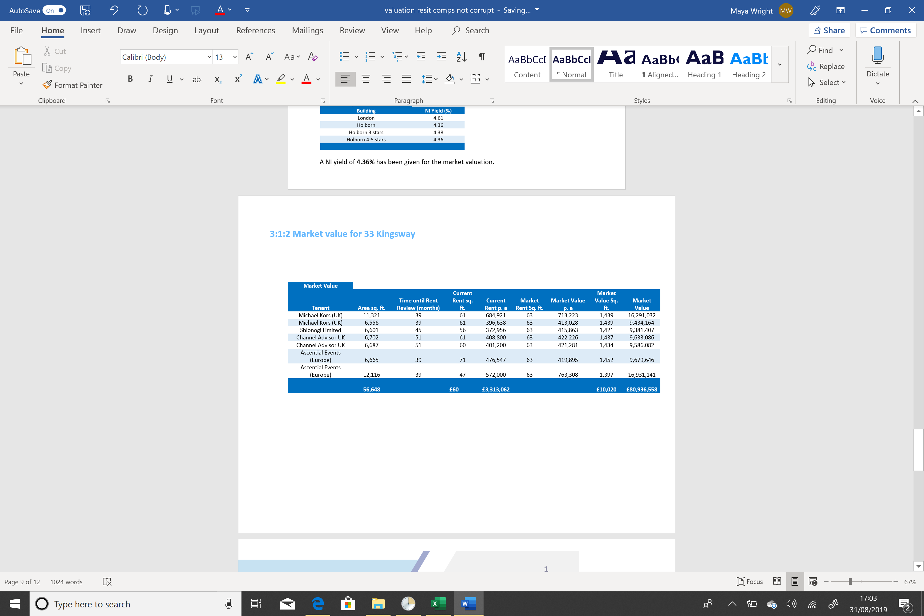

From calculating the market value for each floor of the building the market value for 33 Kingsway has been established at £80,900,000.

|  |
| --- |
| 5:0 Discounted Cash Flow Inputs |

5:1 Assumptions

5:1:1 Purchase price

The purchase price has been assumed at £80,900,000. This has been found from recently achieved market rents within the area.

5:1:2 Stamp Duty

Stamp duty land tax has been set at 4% which is UK standard for a property of this price (Gov.org, 2019). This gives a stamp duty of £3,236,000.

5:1:3 Legal Advice

Legal advice has been assumed at £100,000. This is 0.12% of the purchase price.

5:1:4 Survey Allowance

£404,000 has been given towards a building survey. This is assumed to be enough for a building of this size. This is inclusive of a building, structural, environmental, stamp and M&E survey. This also includes labor costs and agency fees.

5:1:5 Contingency Allowance

A contingency allowance of 0.5% has been given. This can be used for restoration purposes throughout the project life. This totals to £404,500.

5:1:6 Tax Advice

It is assumed that tax advice will be around £30,000 for the project.

5:1:7 Structuring Advice

Structuring advice has been set at 0.01%, totaling £10,000.

5:1:8 Valuation

A valuation is assumed to cost around £25,000 this is industry standard for buildings of this size.

5:1:9 Rental Growth

Rental growth for this property has been forecasted from data collected on the CoStar website. CoStar (2019) forecasts for 4-5 star office buildings in Holborn is 0.8% growth rate p.a.

5:1:10 Exit Yield

An exit yield has been set at 6% p.a. This is assumed to be appropriate as refurbishments will take place with every tenancy ending to keep the 33 Kingsway a prime office location.

5:2 Lease Events and New Lease Assumptions

5:2:1 Estimated Rental Value (ERV)

Tenants that are paying below the market rent prior to their lease review will have their rents adjusted to the market rent. As this is an upwards only lease agreement, those that are paying above market rent prices will not get adjusted down.

5:2:2 Breaks

This report assumes that Shionogi Limited do not exercise their break on the 30/06/2020. This is due to Shionogi Limited paying below market price; therefore, they would struggle to find an office of the same quality around the area for a similar price they are currently paying.

5:2:3 New Tenants

This report assumes Ascential Events (Europe) on the 2nd floor will move when the tenancy agreement ends, this is because Ascential Events 2nd floor is currently paying above the market rent. It has been assumed that LG-1st Ascential Events (Europe) will stay, this is so the company doesn’t have to pay as much in rent this is because LG-1st are currently paying below market rent.

5:2:4 Refurbishment

The opportunity to refurbish a floor will be taken for Ascential Events (Europe) 2nd floor. This is to keep the building up to date with technology and sustainability requirements. A refurbishment cost of £15 sq. ft. has been used for the cash flow, which follows the industry standard according to Bloomfire (2019).

5:2:5 Void Period

A void period of 6 months has been given to floor 2. This is for doing the refurbishments as well as moving new tenants in.

|  |
| --- |
| 6:0 Investment value |

6:0 Acquisition

6:0:1 Total Acquisition cost

Acquisition costs amounted to £85,010,500.

6:0:2 Net Initial Yield

The Net initial yield has been established at 0.56%.

6:1 Exit

6:1:1 Holding period

A holding period of 5 years has been used.

6:1:2 Exit yield

An exit yield of 6% has been assumed. This is in line with prime office builds in central London.

6:1:2 Purchaser costs

Purchaser costs are assumed at 5.75% this is in line with industry standards (Bloomfire, 2019).

6:1:3 Sale costs

Sale costs are assumed at 2.4%, in line with industry standards (Bloomfire, 2019).

6:2 Investment

6:2:1 IRR

An IRR of 4.5% has been established.

6:2:2 Profit

A profit of £18,460,000 making this a good investment.

|  |
| --- |
| 7:0 Sensitivity Analysis |

7:0 Sensitivity Analysis Inputs

7:0:1 Growth Rates

The sensitivity analysis has used increments of 1% between growth rates for analysis.

7:0:2 Exit Yield

The sensitivity analysis has used increment of 1% between exit yields.

7:1 Sensitivity Analysis Output

7:1 Sensitivity Table

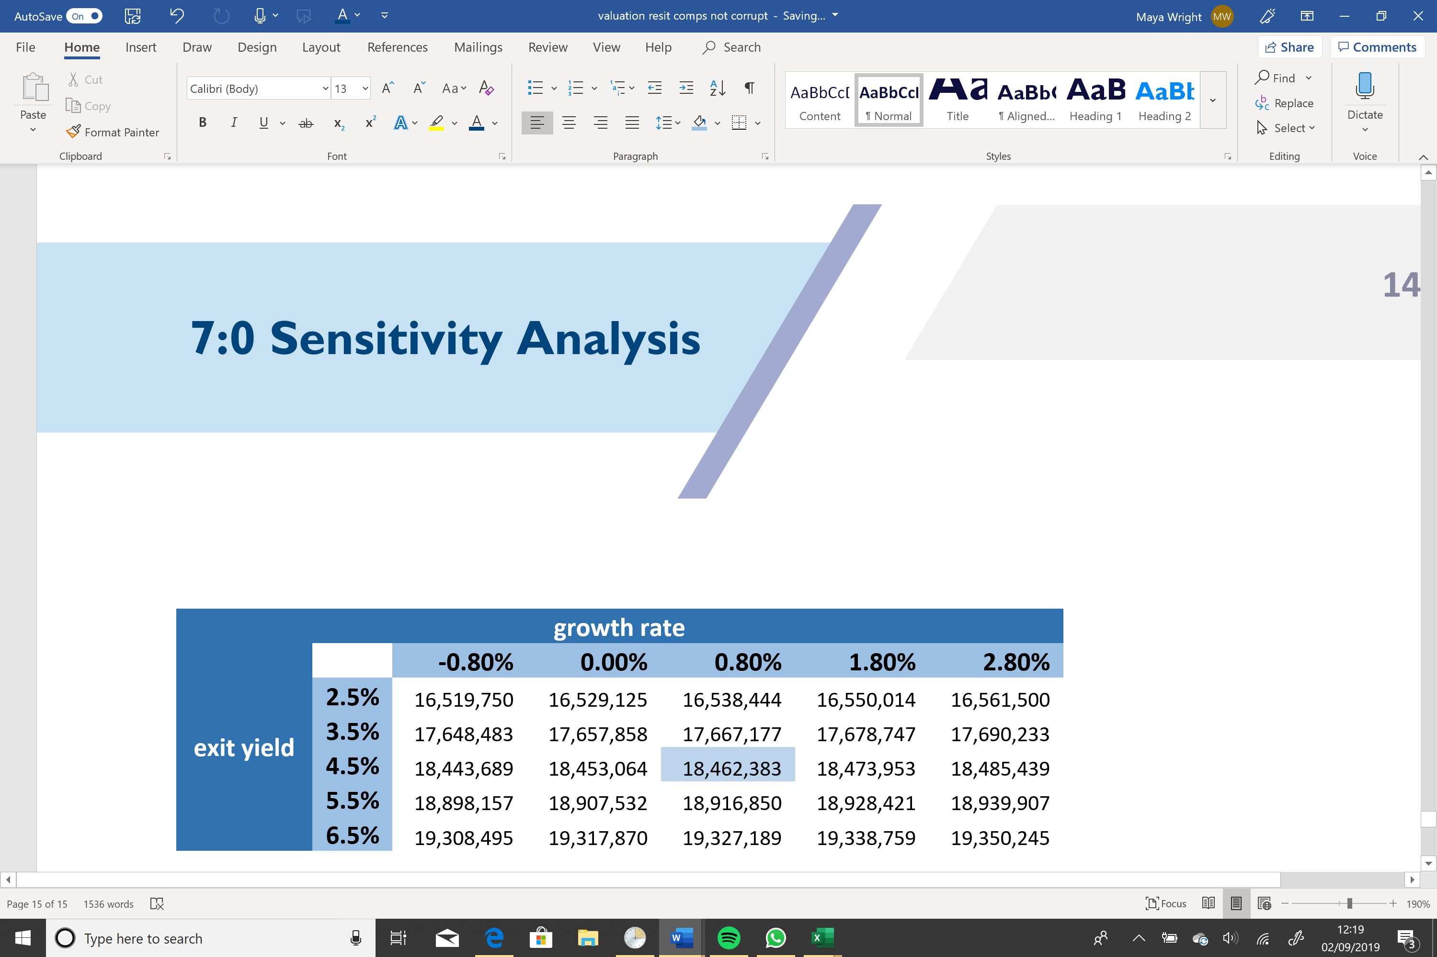

Table : Sensitivity Analysis

As shown in Table 3, the sensitivity of the IRR does not impact the profit that much; therefore, it should be recommended to invest in 33 Kingsway for the purchase price of £80,900,000. The sensitivity analysis shows that a small increase in the exit yield will have a larger increase on the profit than if the growth rate were to increase at the same rate. Exit yield has more volatility at the lower levels.

|  |
| --- |
| 8:0 Conclusions |

8:0 Conclusions

8:0:1 Recommendations

* It is recommended that the £80,900,000 is an appropriate purchase price for this asset. It is forecasted that this asset will acquire £18,460,000 over a holding period of 5 years.
* A recommendation of £15 sq. ft. has been allocated to refurbishment to attract new tenancy agreements.
* All information given is to the best of our company’s knowledge, investors should be aware of uncertainty in the market due to Brexit and other unforeseeable events that may impact the market.

|  |
| --- |
| 9:0 References |

Bloomfire. (2019). *How to build a cashflow.* London: Bloomfire.

Gov.org. (2019, September 1). *Stamp Duty Calculator*. Retrieved from Gov.org: https://www.tax.service.gov.uk/calculate-stamp-duty-land-tax/#/result

MSCI. (2018). *Growth of offices in London.* London: MSCI.

|  |
| --- |
| 10:0 Appendices |

A : Cashflow Assumptions

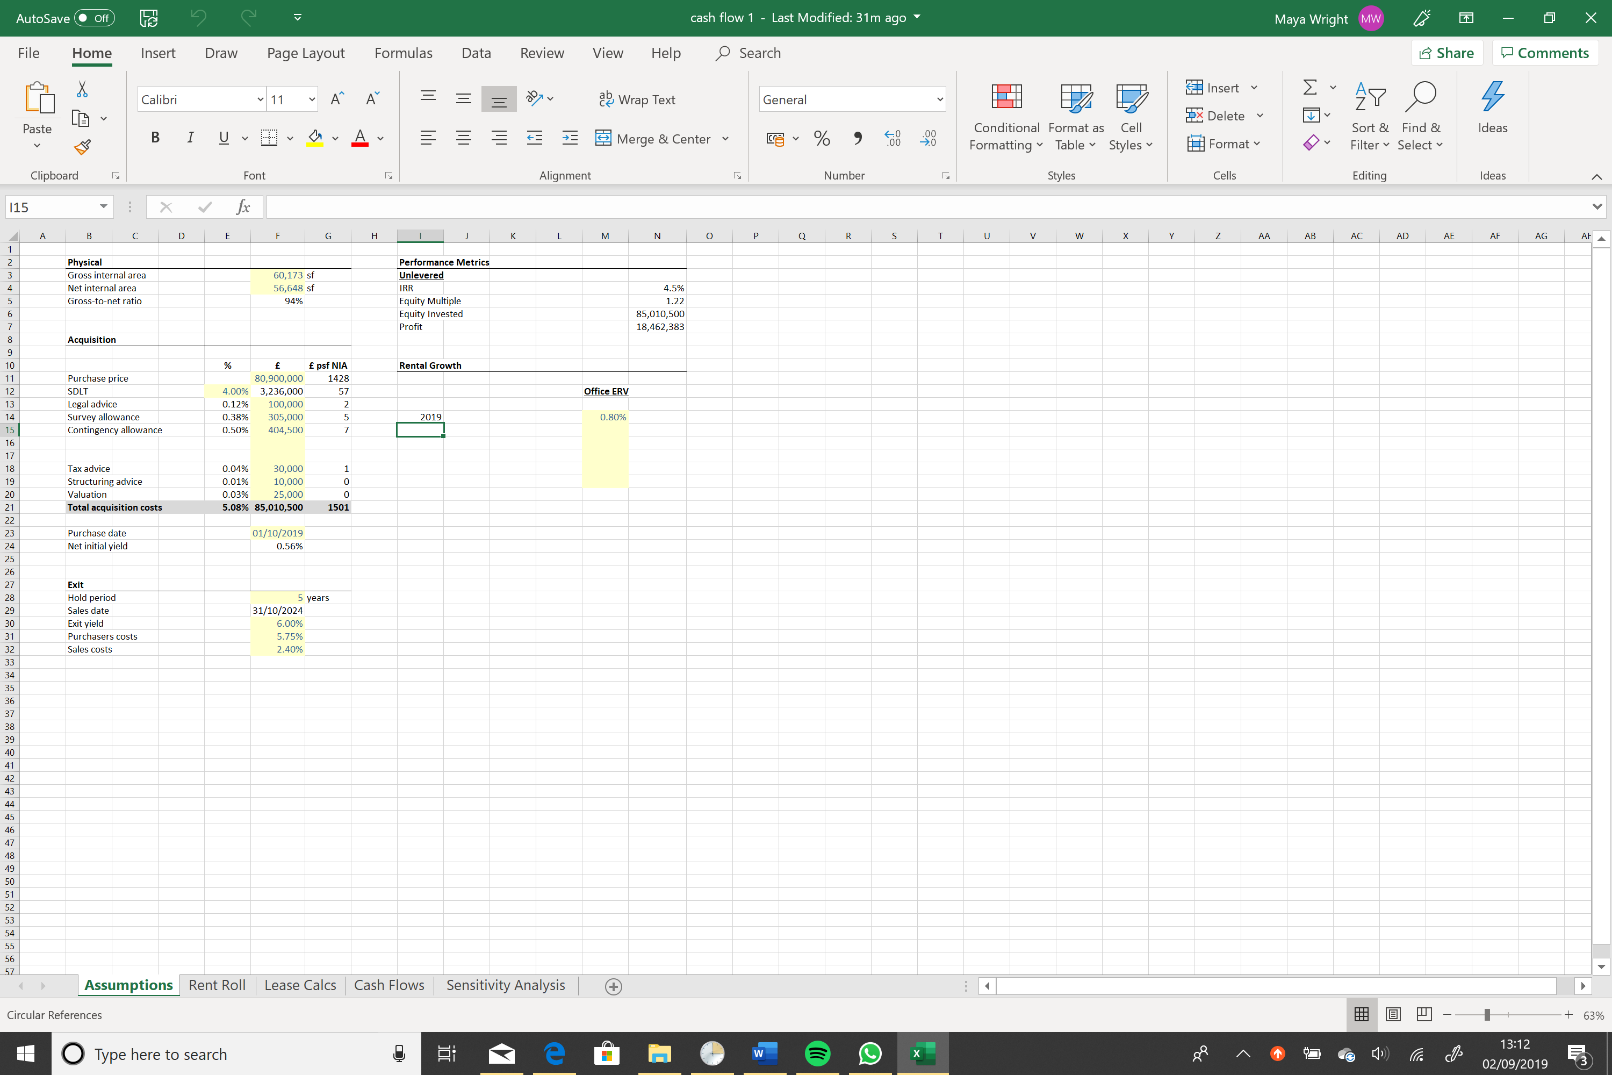

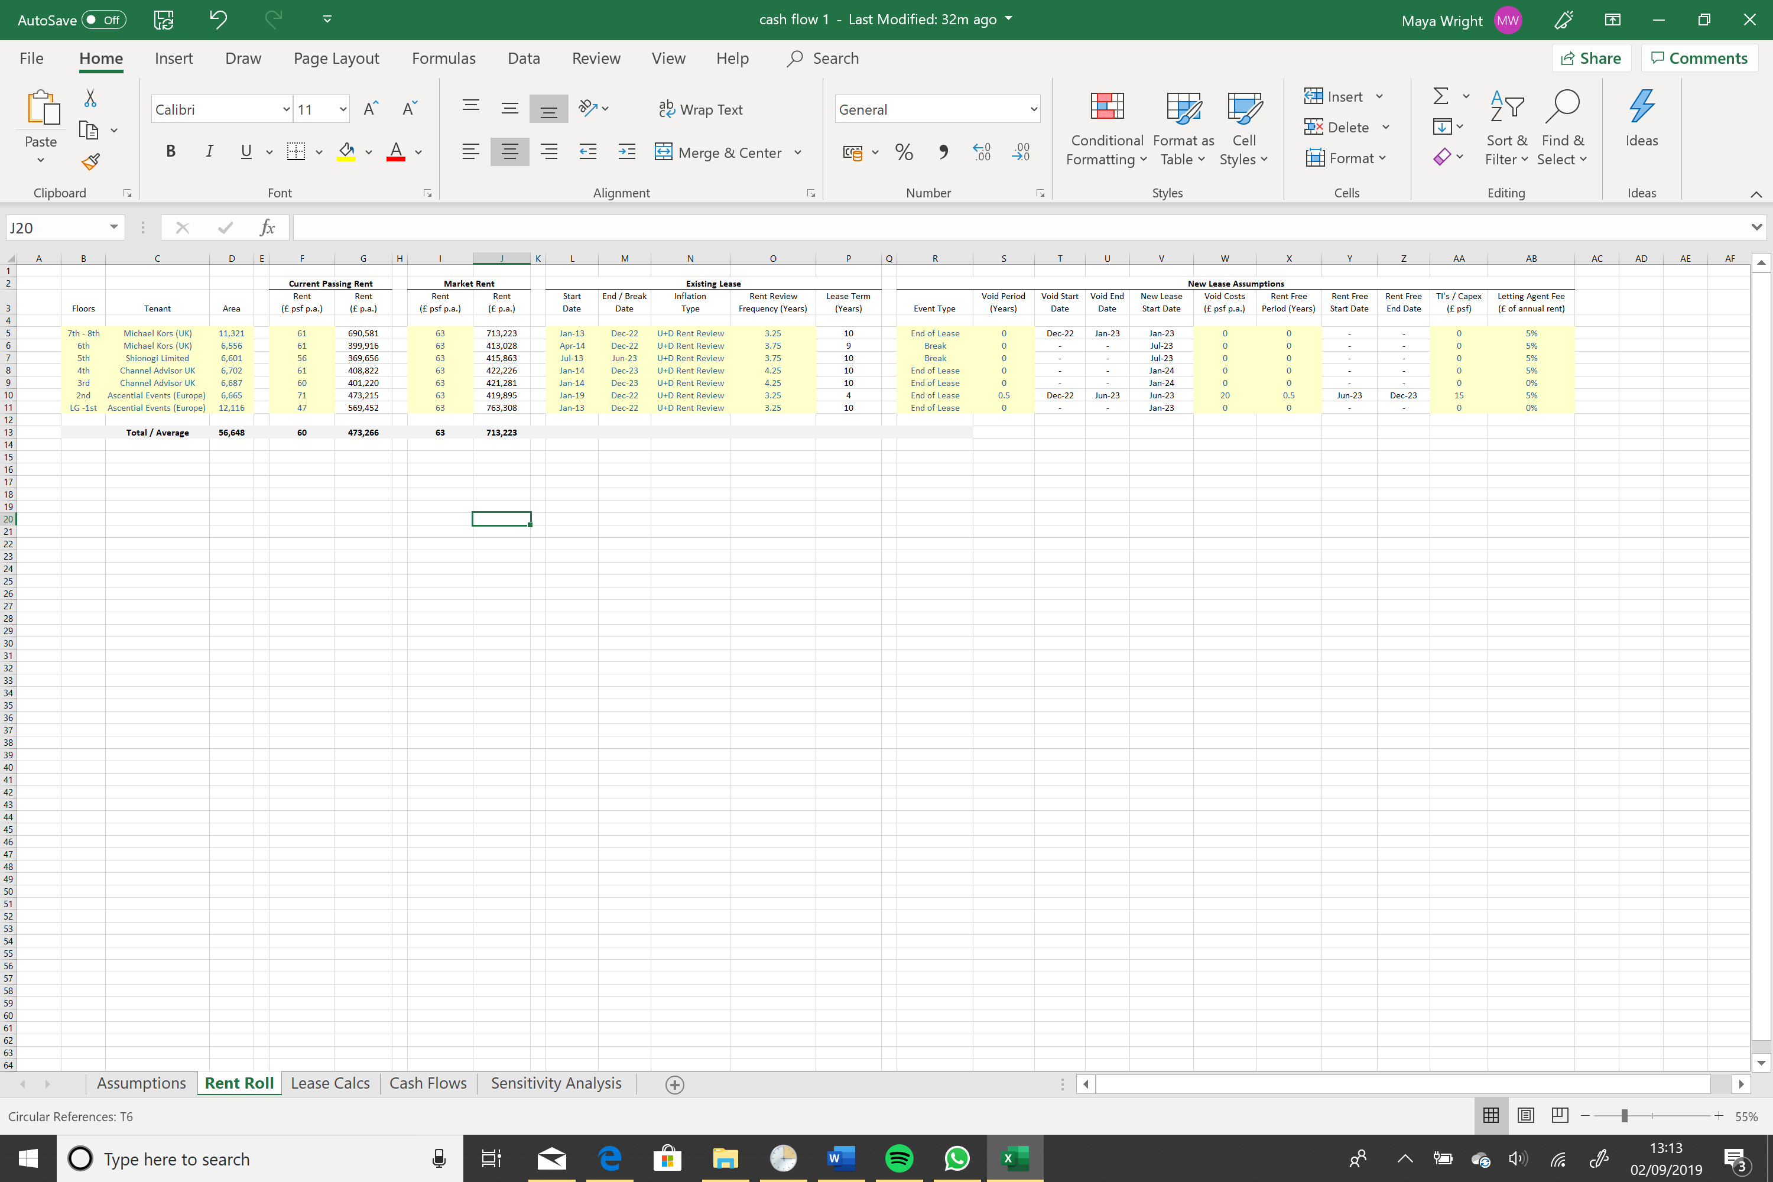B : Rent Roll

C : Lease roll part 1

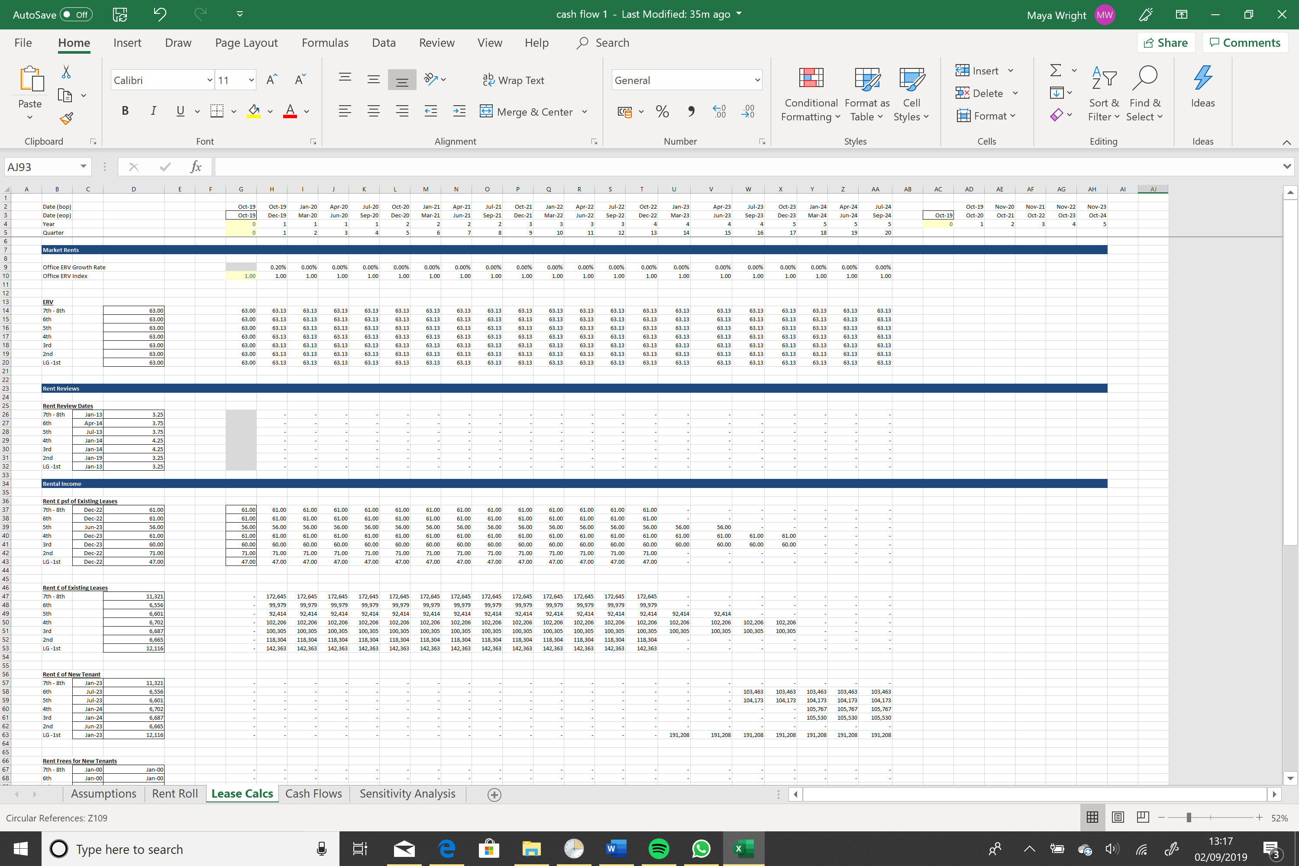

C : Lease roll part 2

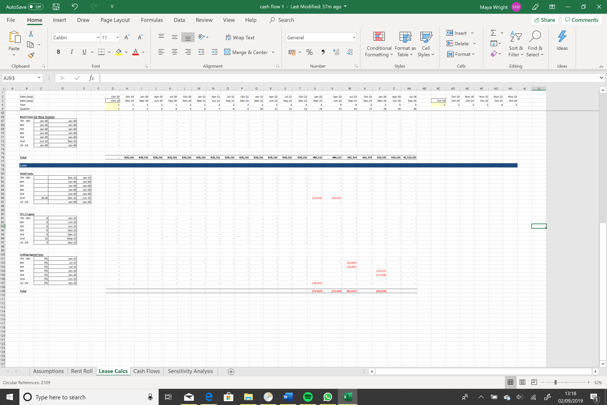

D : Cash flow 